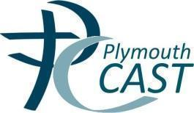

St. Joseph’s Catholic Primary School

Curriculum Design for Reading

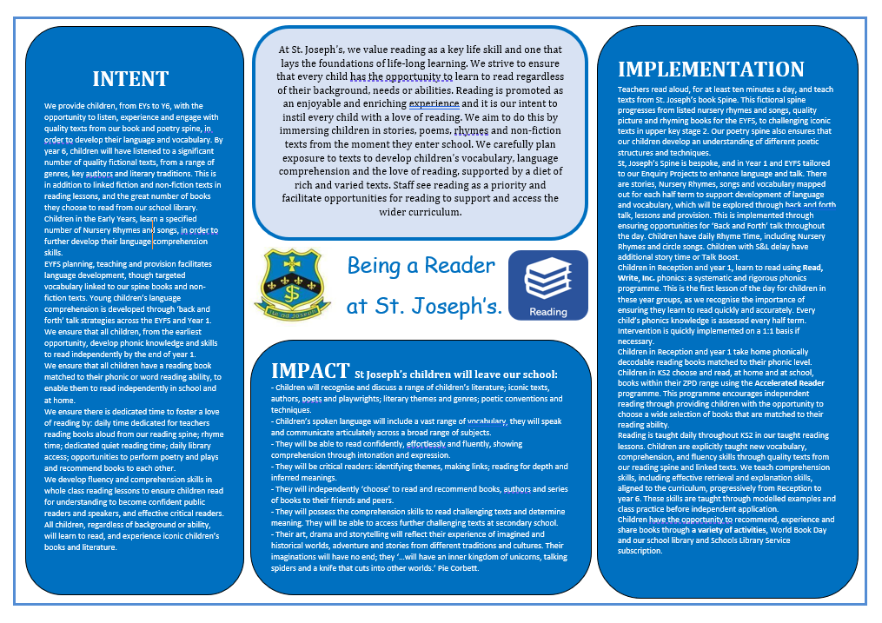
Reading for Pleasure
 | EYFS | Y1 | Y2 | Y3/4 | Y5/6
Intent | Creating a Culture where children are exposed to a range of high-quality texts in a variety of contexts and have opportunity to browse literature as well as structured reading activities.  Pupils should also have opportunities to exercise choice in selecting books and be taught how to do so, with teachers making use of any library services and expertise to support this.  To build preferences in reading and choose to read.  To recognise authors and styles of reading that individuals enjoy  Engaging in book discussions in a range of contexts, alongside adults and peers  Sharing and recommending books.
Implementation | Research shows that children who enjoy reading achieve more highly across the curriculum. Developing a love of books and reading is at the heart of everything we do.  These are some implementations to enhance and promote reading for pleasure:  • We ensure there is an attractive area in each classroom for children to be able to select books from.  • In all reading areas there is access to books that the children are familiar with from St. Joseph’s reading spine and other quality texts.  • In every class, adults will read books during story time exposing children to a greater quality of vocabulary and to wider children’s experiences of different reading genres.  • As a school we recognise getting the balance right between the different skills and processes involved in reading is key to develop successful readers. We therefore build time to discuss with children their reading habits and how they may use self-regulatory strategies to check their understanding.  SLT conduct pupil interviews to look at affective processes and behaviours of reading termly.  • Our library is an attractive and large room with quality displays to entice and encourage children to use. Each class visits the library at least once a week.  We have reading ambassadors from Year 5 and 6 who actively promote a love of reading across the school.  At St. Joseph’s we provide opportunities to enrich children’s reading experiences and interest through half termly themes.  Autumn Term Drop Everything and Read – times across the term where members of our whole school community drop everything and read to a class. Who will be your reader today?  Spring 1 Children’s Choice – this is where children get the chance to ‘take over.’ A new child will be chosen to talk about their book of their choice.  Spring 2 World Book Day – a wealth of activities is planned to help encourage and celebrate reading for pleasure.  Summer 1 Book Buddies – this is where two classes become buddies and have a chance to read to one another each week.  Summer 2 Poetry performance – classes will perform a poem to another unit or in assembly.
Curriculum Provision
Reading Aloud to Children
 | EYFS | Y1 | Y2 | Y3/4 | Y5/6
Intent | Building a bank of story and rhyme knowledge.  Exposing children to texts beyond what they can read themselves.  Develop an enjoyment for reading. |  | Widening knowledge of texts and authors, including non-fiction and poetry  Sustaining stamina in listening and reading texts  Make connections within a book. | Introducing children to wider engage of authors and contexts. | Exposing children to challenging and archaic texts, e.g., language and themes.
Implementation | Minimum of ten minutes reading to class a day using books from St. Joseph’s reading spine. This time is very special and should be the last thing dropped from the curriculum.  .

Early Reading
 | EYFS
Intent | We believe that a love of books and reading should be nurtured and developed from the stage at which children transition to our school community. It is essential that all children are given an equal chance to develop a love of reading and we endeavour to dispel any disparity there may be between those children who have already experienced books and a vocabulary rich environment and those who have not. Beginning our reading journey as soon as possible is vital for future success. Reading is at the core of our curriculum and has been developed in many ways:
Implementation | • We work together with the nursery next door on opportunities for reading. They also use our Library.  All new parents are provided with information about how to successfully promote a love of reading at home with guidance on how to read stories and make them part of their daily routine.  • A core of carefully chosen books are read to the children. These are then put into the continuous provision setting for the children to re-read the familiar stories. Specific vocabulary from the texts is shared, explained and practised within the setting.  • We use a core of traditional stories for the children to become familiar with by returning to and repeating them; thus, developing rich story language, story structure, character development and setting familiarisation.  • We provide an attractive reading area to entice children to explore books independently.  • All children visit the school library weekly and independently choose a book to take home and share. We emphasise to children and parents that their library book has been chosen independently around their own interests, so it supports reading for pleasure.  • Reading activities are threaded throughout the continuous provision to ensure the children are provided with numerous different opportunities to read or be engaged in activities linked to reading or language development.  • There is a focus on oracy in which talk is valued and children feel confident to express themselves and have a voice. Adults have daily conversations encouraging back and forth talk and modelling vocabulary across all areas of learning.  • We create a language rich environment that is purposefully planned to extend a child’s knowledge and thinking with a focus on opportunities for repetition.  • Read Write Inc is introduced immediately upon arrival in Foundation Stage, ensuring the children begin their reading journey as soon as possible. Direct and focussed phonics is taught every day.  • Oral blending/rhyming activities are taught immediately on entrance and threaded throughout the day to enable the children to blend for reading more quickly.  • There are swift assessments of individual progress within the first 3-6 weeks of beginning school. In RWInc children are arranged and into small homogenous groups to suit their level of need.  • Parental involvement is vital to the children’s reading development therefore we provide regular information to inform parents how they can support reading at home. We also identify harder to reach families and offer bespoke reading support and advice.

 | Language Comprehension
Intent | To provide a language rich environment for the children to be exposed to, discuss, and understand more words thus improving their language development. To widen their vocabulary choices in order for them to develop understanding within reading and writing.
Implementation | Enhanced transition opportunities with outside agencies.  Early identification of children with speech, language and communication needs.  Discrete Oracy lessons to enable children to firstly learn to talk and eventually to learn through talk.  Opportunities for listening skills to be developed and explicitly taught.  Adult modelling and reinforcing speaking and listening skills.  A pedagogical approach that encourages participation of all children.  Back and forth talk opportunities carefully planned for and used continuously and incidentally as appropriate.  Carefully chosen reading spine with repetition and specific vocabulary taught from the books.  Reading opportunities planned for and developed over the course of a week.  Ensuring the texts that have been taught are available for the children to use and reread within inviting reading areas.  Planned opportunities for poems and rhymes to be taught.  Workshops for parents to explain the importance of language development.  .

 | Phonics
Intent | There is extensive research and evidence that indicates the ‘...explicit and systematic teaching of the manipulation of phonemes....and phonemic awareness.... is crucial and should be continued until children can automatically process this information. .... There is evidence that the systematic synthetic approach is particularly effective.’  (OFSTED New Inspection Framework – Overview of research) Therefore we use Read Write Inc, a systematic synthetic phonics programme to teach our early reading. It also develops all the components of reading instruction as well as decoding skills at the early stages, including fluency, vocabulary development and comprehension.
Implementation  (See attached phonic progression document) | • We have provided the independent nursery on site with the resources to begin RWInc at the pre-school stage as they feed directly into our FS.  Direct and focussed phonics is taught everyday using Read Write Inc. Children will be taught at the level of their phonological knowledge regardless of age.  • Sessions run for 45 minutes a day in small groups where children are taught to recognise sounds, read decodable green words, red tricky words and alien words. They then practise spelling these words and writing them down. Children are taught to apply their phonics skills and improve fluency through the RWInc story books used during these sessions.  • Children take home reading books that match their phonic knowledge therefore they can read them with success and confidence. There are also activities and questions for children to complete in the front and back of the books.  • There are regular, rigorous and on-going assessments every half term up-dating individual and group needs.  Fluency is developed and strategies for instant word recognition are implemented daily.  • Children who make the slowest progress are identified for responsive intervention in the form of 1:1 coaching which is reviewed and updated half termly.  • We carry out ‘mock’ phonics screening to ensure that children who are in danger of not passing the phonics screening are identified and interventions are put in place. Mock Assessments take place at the end of the autumn and spring term.  • There is a phonics lead who conducts regular ‘drop ins’ to daily lessons. This enables the more experienced practitioner to ‘jump in’ and model best practice providing instant, on the spot training. The phonics lead is able to offer incremental coaching to individuals and regular staff training to ensure staff confidence and competence.  • Parental involvement is highly valued and expected therefore we provide parent meetings to aid them to understand our phonics approach and to help them to use RWInc reading books/activities. There are home learning activities linked to the weekly focus sounds.  • Children new to the school will be assessed and put into the appropriate RWInc group by the end of their first week.  • New staff are introduced to the RWInc online training and are given a buddy in the form of an experienced teacher of phonics.

Independent Reading and Home/School Reading
 | EYFS | Y1 | Y2 |  | Y3/4 | Y5/6
Intent | Independently reading phonically decodable books matched to their phonic knowledge and skills. |  | Reading age-appropriate books Increasing stamina. |  | Choosing appropriate texts Reading for sustained periods of time Increasing the length and complexity of texts being read. Read short novels independently with understanding (by end of Y4) | Reading age-appropriate books, including whole novels Widening the range and challenge of books they read, including texts from a wider literary heritage.
Implementation | New sounds to practise. Decodable books selected based on link to RWInc level. Book they have studied that week and 1 other phonetically matched book. Opportunity to take home a book to share for pleasure in addition to decodable text. |  |  | Books selected based on AR range Teachers monitor through AR reports Opportunity to take home a book in addition to AR book.

Reading Instruction
 | EYFS | Y1 | Y2 |  | Y3/4 | Y5/6
Intent | To teach the decoding and comprehension skills required to achieve age related expectations (as detailed in National Curriculum).
Implementation | Daily RWInc sessions.  Additional, guided reading to ensure independent application and to develop comprehension skills. |  |  | Daily 30-minute whole class reading sessions: teacher focusing with at least one group per day and pupils grouped by need rather than ability. Included in reading sessions:  Expert and echo reading – opportunities for children hear an ‘expert’ read texts and for them to echo the smoothness, expression, volume, phrasing and pace to develop fluency.  Focus on learning new vocabulary particularly 2 tier words.  Opportunities for book talk using stem sentences to enable the children to structure their answers and develop a depth of understanding.  Specific comprehension skills are taught. (see progression table)  Independent activities enabling children to practise and apply reading skills (when not in guided group with teacher) An increasing expectation of written recording of understanding through KS2.
Accelerated Reader
Y2 – Y6
Intent | Accelerated Reader is the tool we use for all children who have completed RWInc. Four times a year, tests determine the child’s reading range (zone of proximal development) and books are chosen to ensure they are reading at the appropriate level. As soon as they have finished their book, children complete an online quiz, which helps us determine their level of comprehension. Teachers will often conference with children based on the outcome of their quizzes. This allows us to track progress and encourage children to progress through the reading scheme at an appropriate pace. Each half term teachers will give children a personal target, generated by the programme, based on their reading age. Children need to read enough books and pass enough quizzes to pass their points target. Once they have reached their target certificates will be awarded in our half termly reading assembly. Children can also join our ‘Millionaire Club’ when they have read over a million words and will be awarded with a special certificate and small prize.

Progression of Comprehension Skills
Skills | EYFS | Y1 |  | Y2 |  | Y3 |  | Y4 |  | Y5 |  | Y6
Retrieve and Explain | Children answer simple recall questions verbally about stories they can follow without pictures and prompts. | Children verbally explain their understanding of what is being read to them by answering simple questions about what has just happened. |  |  | Children explain their understanding of what they have read themselves by answering simple questions about what has just happened. |  | Children are taught and begin to use skimming and scanning to retrieve and record details from fiction and non-fiction, using some quotations.  Discuss  understanding |  | Children use skimming and scanning to retrieve and record details from fiction and non-fiction, using relevant quotations to support responses.  Discuss  understanding | Children begin to use skimming, scanning and reading before and after to retrieve and record information, using evidence from a larger part of the text.  Explain and discuss understanding of what they have read, including through formal presentations and debates, maintaining a focus on the topic and using notes where necessary. |  |  | Children use skimming, scanning and reading before and after to retrieve and record information, using evidence from across the text.  Explain and discuss understanding of what they have read, including through formal presentations and debates, maintaining a focus on the topic and using notes where necessary.
Authorial Intent  Structural Choices | Develop familiarity with key stories, fairy stories and traditional tales, retelling them and considering their characteristics. |  |  |  | Discuss the sequence of events in books and how items of information are related.  Begin to understand non-fiction books that are structured in different ways. |  | Read books that are structured in different ways.  Identify how structure contributes to meaning.  Recognise some different forms of poetry. |  |  | Understand what they read by identifying how structure and presentation contribute to meaning.
Authorial Intent  Linguistic Choices | Discuss word meanings. |  |  |  | Discuss favourite words and phrases.  Discuss and clarify the meanings of words, linking new meanings to known vocabulary. |  | Discuss words and phrases that capture the reader’s interest and imagination.  Identify how language contributes to meaning in books that can be read independently. |  |  | Identify how language contributes to meaning.  Discuss and evaluate how authors use language, including figurative language, considering the impact on the reader.  Distinguish between statements of fact and opinion.
Form an Opinion | Participate in discussion about what is read to them, taking turns, and listening to what others say. |  |  |  | Pupils should discuss their favourite words and phrases. |  | Participate in discussion about both books that are read to them and those they can read for themselves, taking turns and listening to what others say. |  |  | Provide reasoned justifications for their views.
Summarising | Recall and order some key events from the text. They also introduce a story line or narrative in their play. |  | Retell and sequence main events from texts and discuss how the events are related, focussing on the main content of the text. |  | Retell and sequence events from texts and discuss how the events are related and how they shape the story, focussing on the main content of the text. |  | Begin to distinguish between important and unimportant information in a text drawn from more than one paragraph and synthesise the key points to give a brief verbal summary. Teachers model how to record for children to begin. |  | Distinguish between important and unimportant information in a text drawn from more than one paragraph and synthesise the key points to give a brief written summary. | Summarise information from across a text drawn from more than one paragraph; identifying key details that support the main ideas and make connections by analysing, evaluating, and synthesising ideas within a text. |  | Summarise information from across a text drawn from more than one paragraph; identifying key details that support the main ideas and make connections by analysing, evaluating, and synthesising ideas within and between texts.
Make Connections  Theme and Conventions | Link what they read or hear read to their own experiences.  Discuss word meanings, linking new meanings to those already known.  Children should learn to understand both the books they can already read accurately and fluently and those they listen to by drawing on what they already know or on background information and vocabulary provided by the teacher. |  |  |  | Discuss the sequence of events in books and how items of information are related.  Discuss and clarify the meanings of words, linking new meanings to known vocabulary.  To understand both the books that they can already read accurately and fluently and those that they listen to by drawing on what they already know or on background information and vocabulary provided by the teacher. |  | Identify themes and conventions in a wide range of books. |  |  | Develop understanding of what they read by making comparisons within and across texts.
Clarify | Understand what they read by checking that the text makes sense to them as they read and correcting inaccurate reading. |  |  |  | Discuss and clarify the meanings of words, linking new meanings to known vocabulary.  Pupils should understand what they read by checking that the text makes sense to them as they read and correcting inaccurate reading. |  | Use dictionaries to check the meaning of words that they have read.  Check that the text makes sense to them.  Discuss understanding and explaining the meaning of words in context in books that can be read independently. |  |  | Understand what they read by checking that the book makes sense to them.  Discussing their understanding and exploring the meaning of words in context.
Predict | Makes suggestions about what might happen next or how the story might end based on actions so far and innovates stories through role play. |  | Use their own knowledge, as well as what has happened so far in a story, to make sensible predictions about what could happen next and begin to explain them verbally and through pictures. |  | Use their own knowledge, as well as what has happened so far in a story, to make sensible predictions about what could happen next and give explanations of them. |  | Use relevant prior knowledge to form predictions and justify them. Children are taught the skill of using details from the text to form further predictions from details stated and implied in books they can read independently. |  | Use relevant prior knowledge, as well as details from the text to form predictions and justify them from details stated and implied in books they can read independently.  Monitor predictions, and compare them with the text as they read on | Predictions are supported by relevant evidence drawn from the text. Confirm and modify predictions from details stated and implied as they read on. |  | Predictions are supported by relevant evidence drawn from across the text or from a wider context (genre, author knowledge etc). Children confirm and modify predictions from details stated and implied in light of new information.
Infer | Infer characters’ feelings using pictures and own experiences to talk about them. |  | Make inferences about a characters’ feelings using what they say and do to infer more obvious points with direct references to pictures and words in the text. |  | Make inferences about a characters’ feelings using what they say and do to infer more obvious points and begin to pick up on some more subtle references. |  | Children infer characters’ feelings, thoughts and motives from their stated actions.  Begin to justify inferences with evidence directly from the texts they can read independently and/or life experience, with some reference to a specific point in the text. |  | Children infer characters’ feelings, thoughts and motives from their stated actions.  Consolidate justifying inferences with evidence directly from the texts they can read independently and/or life experience, with some reference to a specific point in the text. |  | Children infer characters’ feelings, thoughts and motives, giving one or two pieces of evidence to support each point made, beginning to draw evidence from different places across the text.
Question | Listen to stories, responding to what they hear with relevant questions to aid understanding. |  | Give a simple explanation about the information, characters and events in books or texts that have been read to them. |  | Answer and ask simple questions about age-appropriate texts that they listen to and those that they read for themselves, explaining what they have learned. |  | Ask simple questions to improve their understanding of a text. |  | Ask a range of questions to improve their understanding of an age-appropriate text, often trying to find more information to solve a problem for themselves. |  | Ask a range of questions to improve their understanding of what they have read, appropriate to the task, and give clear explanations and reasons for their views. |  |  | Ask targeted, well-constructed questions to improve their understanding of a text, giving focused explanations, presentations and detailed reasons for their views.

Shared Reading as Part of Teaching Sequences
 | EYFS | Y1 | Y2 | Y3/4 | Y5/6
Intent | Exposing children to a high-quality text model in a variety of text types, as models for writing at a higher level than all children could access independently.
Implementation | First week of each teaching sequence: sharing the text, providing opportunities to respond to the text, provide opportunities to map and learn the text, exploring text structure summarise text features (reading objectives identified on sequence planning)
Core Reading Texts to Support Reading to Learn Across the Curriculum
 | EYFS | Y1 | Y2 | Y3/4 | Y5/6
Intent | Listen to and discuss Traditional Tales, Nursery Rhymes, Circle Songs and Action Rhymes, information books, other non-fiction and related narrative/poetry texts to establish the foundations for their learning in other subjects. |  | Listen to, discuss and read independently, texts which develop their knowledge across the wider curriculum | Listen to and read a wide variety of texts to find out information and develop knowledge across the wider curriculum. | The skills of information retrieval should be applied in reading textbooks from across the curriculum and in contexts where pupils are genuinely motivated to find out information.
Disadvantaged Pupils and Children with SEND
 | EYFS | Y1 | Y2 | Y3/4 | Y5/6
Intent | To ensure we meet the needs of our disadvantaged children, including Children Looked After, those eligible or Pupil Premium funding and those with SEND, building confidence and raising self-esteem.
Implementation | We use phonic based resources to support our children with limited literacy skills and they work because they are non-threatening, and pupils can go at their own pace. Our targeted intervention is tailored around pupil’s specific starting points. Learning is bite-size, multi-sensory and repetitive.
Assessment
 | EYFS | Y1 | Y2 | Y3/4 | Y5/6
Assessment Evidence | Base Line assessment  EYFSP  Phonic Screening Check  Observations of reading behaviour and talking to pupils  Independent and home reading records  Running records to assess fluency and accuracy.  Regular and rigorous phonic assessments |  | SATs Phonics Screening Check  Observations of reading behaviour & talking to pupils Independent and home reading records Guided reading records Running records to assess fluency and accuracy.  AR star tests and quizzes  SATs papers | AR star tests and quizzes  NFER termly tests  Observations of reading behaviour & talking to pupils  Independent and home reading records  Verbal and written book reviews & recommendations Written responses to reading activities | Yr 6 SATs  SATs papers  AR star tests and quizzes  NFER termly tests  Observations of reading behaviour & talking to pupils  Independent and home reading records  Verbal and written book reviews & recommendations Written responses to reading activities
Assessment Expectations
Early Reading
Below is the minimum number of sounds known expected by the end of a given term as suggested by RWInc, the phonic programme we use.
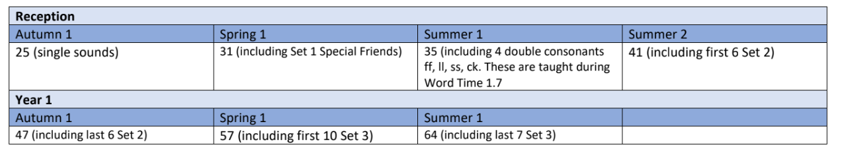
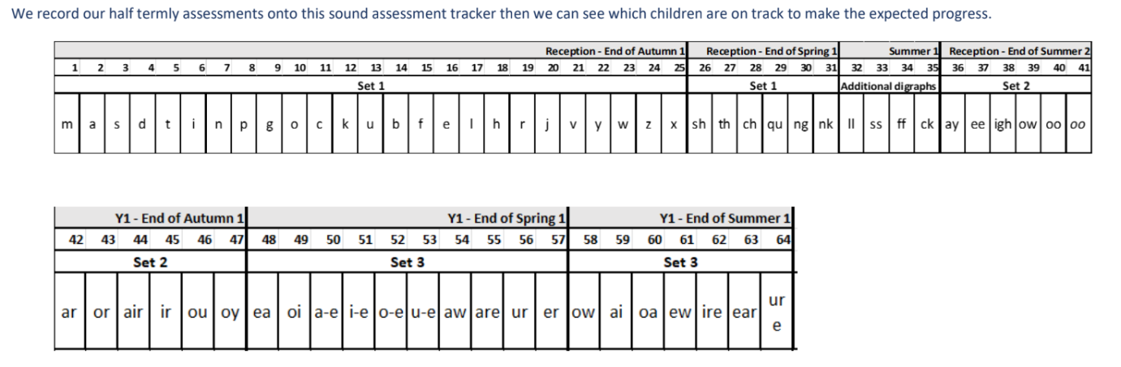
End Points in Reading
Clear “end-points” for reading, establishing what our pupils need to know and be able to do at the end of KS1, end of year 4 and then the end of KS2. We use the National Curriculum statutory requirements to inform our assessments.

 | End of KS1 | End of lower Key Stage 2 | End of lower Key Stage 2
Word Reading | Children will:  • continue to apply phonic knowledge and  skills as the route to decode words until  automatic decoding has become  embedded and reading is fluent  • read accurately by blending the sounds  in words that contain the graphemes  taught so far, especially recognising  alternative sounds for graphemes  • read accurately words of two or more  syllables that contain the same  graphemes as above  • read words containing common suffixes  • read further common exception words,  noting unusual correspondences  between spelling and sound and where  these occur in the word  • read most words quickly and accurately,  without overt sounding and blending,  when they have been frequently  encountered  • read aloud books closely matched to  their improving phonic knowledge,  sounding out unfamiliar words  accurately, automatically and without  undue hesitation  • re-read these books to build up their  fluency and confidence in word reading. | Pupils should be taught to:  • apply their growing knowledge of root words,  prefixes and suffixes (etymology and morphology)  both to read aloud and to understand the meaning  of new words they meet  • read further exception words, noting the unusual  correspondences between spelling and sound, and  where these occur in the word | Pupils should be taught to:  • apply their growing knowledge of root  words, prefixes and suffixes (morphology  and etymology), both to read aloud and  to understand the meaning of new words  that they meet.
Comprehension | Pupils will be taught to:  develop pleasure in reading, motivation  to read, vocabulary and understanding  by:  • listening to, discussing and expressing  views about a wide range of  contemporary and classic poetry, stories  and non-fiction at a level beyond that at  which they can read independently  • discussing the sequence of events in  books and how items of information are  related  • becoming increasingly familiar with and  retelling a wider range of stories, fairy  stories and traditional tales  • being introduced to non-fiction books  that are structured in different ways  • recognising simple recurring literary  language in stories and poetry  • discussing and clarifying the meanings of  words, linking new meanings to known  vocabulary  • discussing their favourite words and  phrases  • continuing to build up a repertoire of  poems learnt by heart, appreciating  these and reciting some, with  appropriate intonation to make the  meaning clear  Understand both the books that they can  already read accurately and fluently and those  that they listen to by:  • drawing on what they already know or  on background information and  vocabulary provided by the teacher  checking that the text makes sense to  them as they read, and correcting  inaccurate reading  • making inferences on the basis of what is  being said and done  • answering and asking questions  • predicting what might happen on the  basis of what has been read so far  • participate in discussion about books,  poems and other works that are read to  them and those that they can read for  themselves, taking turns and listening to  what others say  • explain and discuss their understanding  of books, poems and other material,  both those that they listen to and those  that they read for themselves | Develop positive attitudes to reading and understanding of  what they read, by:  listening to and discuss a wide range of fiction,  poetry, plays, non-fiction and textbooks  • reading books that are structured in different ways  and reading for a range of purposes  • using dictionaries to check the meaning of words  that they have read  • increasing their familiarity with a wide range of  books, including fairy stories, myths and legends,  and retelling some of these orally  • identifying themes and conventions in a wide range  of books  • preparing poems and play scripts to read aloud and  to perform, improve intonation, tone and volume  • discussing words and phrases that capture the  reader’s interest and imagination  • recognising some different forms of poetry [for  example, free verse, narrative poetry]  Understand what they read, in books they can read  independently, by:  • checking that the text makes sense to them,  discussing their understanding, and explaining the  meaning of words in context  • asking questions to improve their understanding of a  text  • drawing inferences such as inferring characters’  feelings, thoughts and motives from their actions,  and justifying inferences with evidence  • predicting what might happen from details stated  and implied  • identifying main ideas drawn from more than 1  paragraph and summarising these  • identifying how language, structure, and  presentation contribute to meaning  • retrieve and record information from non-fiction  • participate in discussion about both books that are  read to them and those they can read for  themselves, taking turns and listening to what  others say | Maintain positive attitudes to reading and  understanding of what they read by:  continuing to read and discuss an  increasingly wide range of fiction, poetry,  plays, non-fiction and reference books or  textbooks  • reading books that are structured in  different ways and reading for a range of  purposes  • increasing their familiarity with a wide  range of books, including myths, legends  and traditional stories, modern fiction,  fiction from our literary heritage, and  books from other cultures and traditions  • recommending books that they have  read to their peers, giving reasons for  their choices  • identifying and discuss themes and  conventions in and across a wide range  of writing  • making comparisons within and across  books  • learning a wider range of poetry by heart  • preparing poems and plays to read aloud  and to perform, showing understanding  through intonation, tone and volume so  that the meaning is clear to an audience  Understand what they read by:  • checking that the book makes sense to  them, discussing their understanding and  exploring the meaning of words in  context  • asking questions to improve their  understanding  • drawing inferences such as inferring  characters’ feelings, thoughts and  motives from their actions, and justifying  inferences with evidence  predicting what might happen from  details stated and implied  • summarising the main ideas drawn from  more than 1 paragraph, identifying key  details that support the main ideas  • identifying how language, structure and  presentation contribute to meaning  • discuss and evaluate how authors use  language, including figurative language,  considering the impact on the reader  • distinguish between statements of fact  and opinion  • retrieve, record and present information  from non-fiction  • participate in discussions about books  that are read to them and those they can  read for themselves, building on their  own and others’ ideas and challenging  views courteously  • explain and discuss their understanding  of what they have read, including  through formal presentations and  debates, maintaining a focus on the topic  and using notes where necessary  • provide reasoned justifications for their  views

